Civil Air Patrol Check-In Application
CAP Check-In Application Version 3.0
This guide provides installation, launch, and usage instructions for the CAP Check-In Application. It includes the latest 2.2 improvements, shortcut launch options, and tab navigation.

- Overview
The CAP Check-In Application simplifies event attendance tracking. It supports barcode scanning or manual CAPID entry, member lookup, attendance logging, and export to eServices.
- System Requirements
  - Windows 10 or newer
  - USB barcode scanner (recommended)
  - Optional speakers for audio feedback
  - Optional network or shared drive access for multi-computer use
- Installing the Application
  - Option1: Run the CAPCheckIn_Installer_X.X.exe. Select a dedicated folder or if an upgrade, the folder it is already in. Do not include the version number in the folder name. The shortcuts put on the desktop enable different tabs to be available based on needs for the computer.
Note: The installer can also be used to create the shortcuts on a computer that does not have them.
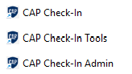
  - Option 2: Copy CAPCheckIn.exe to a dedicated folder. Do not include the version number in the folder name.
  - For either option, If using multiple computers, place the folder on a shared network drive or synced folder. Each computer can run the same executable from that shared location.
  - Run CAPCheckIn.exe. Use the Admin shortcut to get all options.
- On first launch, the application creates required folders and files in the working directory and prompts for the event name.
- Launch Modes and Shortcuts
  - The application supports three launch modes:
  - Regular launch: CAPCheckIn.exe opens the standard check-in interface.
  - Tools mode: CAPCheckIn.exe --tools opens the Tools tab only.
  - Admin mode: CAPCheckIn.exe --admin opens all available tabs, including Tools, Attendees, and Active Scanners.
  - Create separate shortcuts for each mode if helpful.
- Tabs and Usage
  - Check-In Tab
This is the main check-in interface. Scan or type CAP IDs. If you use a barcode scanner, program the scanner to do a return after the scan. For a typed in CAPID, hit enter.
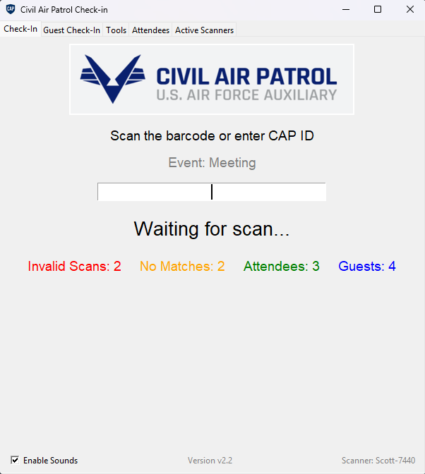
Invalid Scans are entries that do not match expected input. All CAPIDs are 6 numbers starting with 1-7. Invalid scans do not count as Attendees and are recorded in the errors folder. If getting random invalid scans from a barcode scanner, it is low quality or seeing something it counts as a scan. Try using a blank sheet of paper as a scan surface.
No Matches are entries that seem valid but there is no match in the members.csv file. These are counted in the Attendee count also. If a valid CAPID is scanned but not a member of the squadron, they do not need to register as a guest. eServices will still record their attendance when uploaded.
Attendees count is the number of successful check-ins including any that do not have a match. Does not include guests.
Guests are the number of guests. Normally this is prospective cadets or senior members.
  - Guest Check-In Tab
The Guest Check-In Tab can be used to record name and email address of non-CAP members.
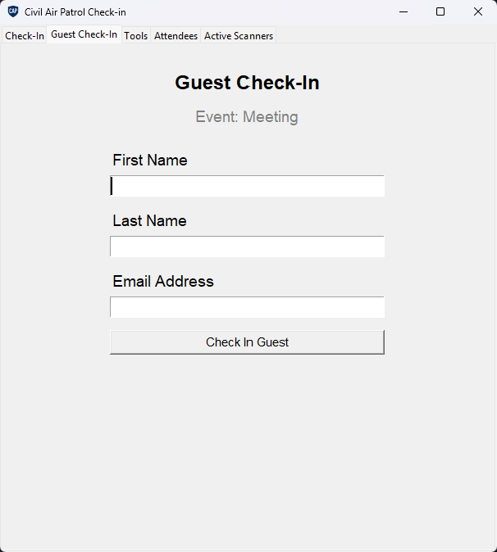
  - Tools Tab
The Tools tab is available in Tools mode and Admin mode.
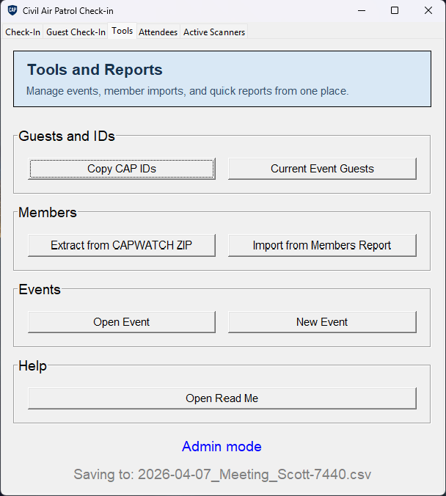
Copy CAP IDs will copy the CAPID in CSV format for easy paste into eservices.
Current Event Guests will open a separate window with a list of guests. The print button will open the list in Notepad for easy copying or printing.
Extract from CAPWATCH ZIP will open a file picker. Navigate to the location of the CAPWATCH zip file. Click on the file and click Open. Most CAP members do not have access to CAPWATCH for data security concerns.
Import from Members Report will open a file picker. Navigate to the location of the Membership.csv file downloaded from eServices, Reports, Member Reports, Member Reports, Reports = Membership. If you do not have access to Member Reports, ask another Senior Member to do it or request access. Access is granted by someone in your squadron.
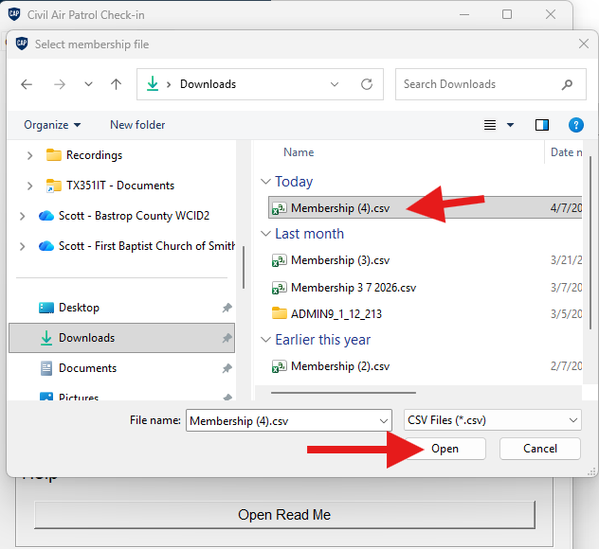

To download a member report:
Log into eServices and select Member Report under Reports
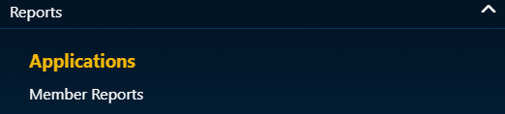
Click on Member Reports at the top.
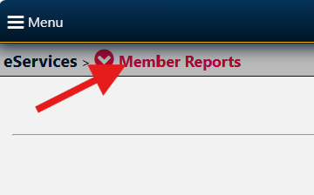
Select Member Reports under Modules (Not under Home)
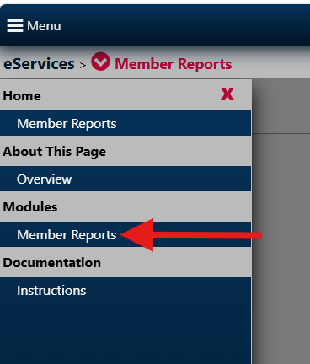
Select Membership in the Reports dropdown.
Select Unit
Select what to include
Select Member Type
Select CSV as the Report Format
Click View Report
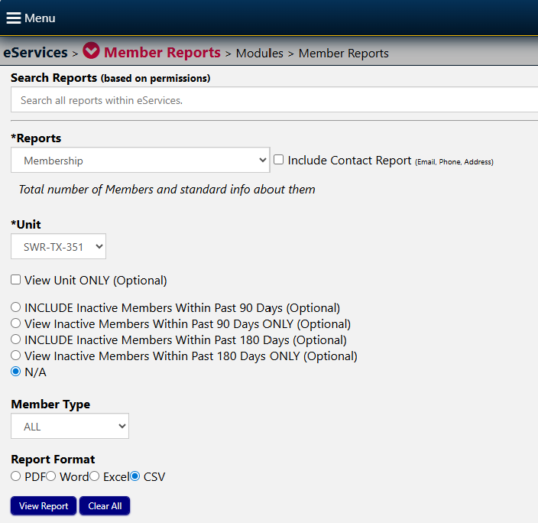
The report is downloaded on your computer. Most likely into the downloads folder.
  - Attendees Tab
The Attendees tab shows live attendee details, search, and sort controls. Filter attendees by CAPID or name using the Search box. The print button opens the list in Notepad for easy copy or printing.
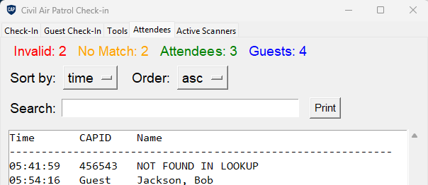
  - Active Scanners Tab
The Active Scanners tab shows current scanner activity when multiple computers run from the same shared folder.

- eServices Attendance Import
After check-in, click Copy CAP IDs. A eService friendly list of CAPID is now in the clipboard waiting to paste into eService Attendance.
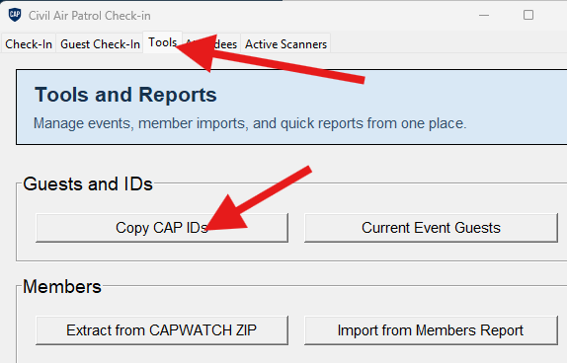

To upload attendance into eService:
Log into eServices and select Attendance Log under Personnel
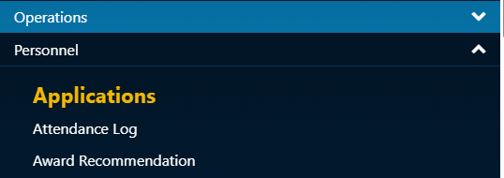
Create a new meeting or select an existing meeting
Select Organization, Prepopulate attendees or not (I do not), Meeting Start Date, Meeting End Date, Member Type, Location, Meeting Notes, select topics that were covered at this event and click create.
NOTE: Selecting Safety Briefing DOES NOT count as the official record for Safety Briefings. To record attendance for a Safety Briefing, you must input it in CAPSIS.
If you selected to prepopulate the list, all members will be listed as Present. Use the Toggles All option to untoggled everyone before bulk input.
Paste the list from the clipboard into he bulk entry field. Validate the information and click Save Attendance. YOU MUST CLICK Save Attendance at the bottom.
